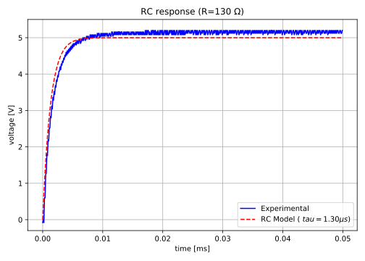
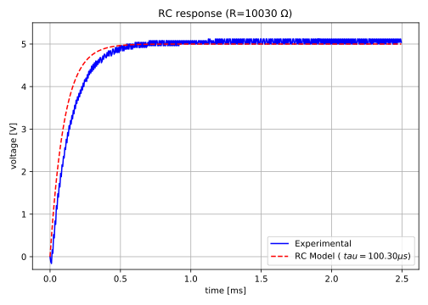
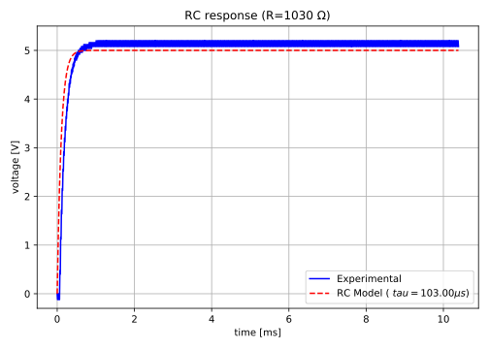
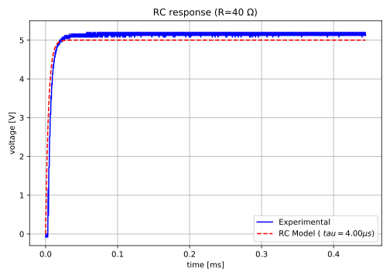
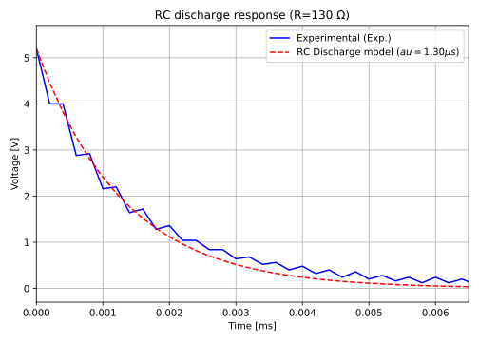
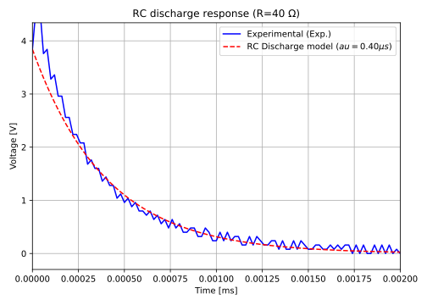

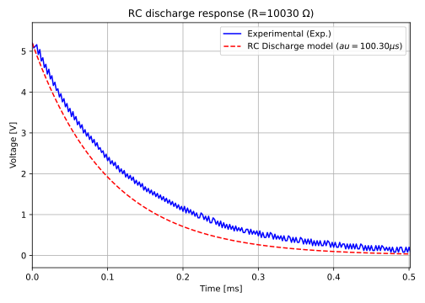
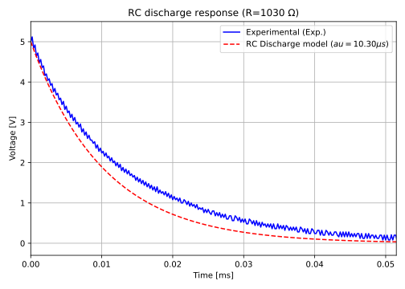
$$R_{int}$$ | $$R_{ext}$$ | $$R_{tot}$$ | C | $$τ=R_{tot}*C(μs)$$ | $$τ_{exp}(μs)$$ | Error (%)
30 | 10 | 40 | 1e-8 | 0.4 | 0.5 | 25
30 | 100 | 130 | 1e-8 | 1.3 | 1.8 | 38.5
30 | 1000 | 1030 | 1e-8 | 10.3 | 13 | 26.2
30 | 10000 | 10030 | 1e-8 | 100.3 | 140 | 39.6

RLC circuit
